Willis Firebots Robotics Team Sponsor Proposal
Willis Junior High School
401 South McQueen Road
Chandler, AZ 85225
480.883.5700

To Whom It May Concern,

My name is Jason Prichard. I teach 7th and 8th science at Willis Junior High School in Chandler, Arizona. I am also the teacher sponsor and coach of our school robotics team, The Willis Firebots. I am writing you concerning a sponsorship opportunity with the Willis Firebots Robotics Team. The support of your organization can help me achieve my goal to provide a fun and engaging learning opportunity for students interested in Science Technology Engineering and Mathematics (STEM) fields. I am currently seeking sponsors to help fund some of the expenses of maintaining our team. Your contribution will help us pay for tournament registration fees, purchasing parts and equipment, team jerseys for students, transportation to events, and programming software. Your company logo will appear on our team jerseys, team banner, and our team website. Sponsors who wish to be a Team Partner also have their logo prominently displayed on one of our competition robots. For more detail about the Willis Firebots Robotics Team and what we do, read on.

School Description
Willis Junior High School – located in Chandler, Arizona – serves an ethnically, and socioeconomically diverse community. Approximately 900, seventh and eighth grade students attend Willis. The demographic of the school is reflective of the local community: approximately 50% Hispanic, 34% Anglo, 10% African American, 4% Asian, and 2% Native American. Willis is located in an established urban area, and as such, addresses the needs of one of Chandler’s oldest and most economically depressed communities. Approximately 58% of our student population receives free or reduced price lunch (51% free, 7% reduced).
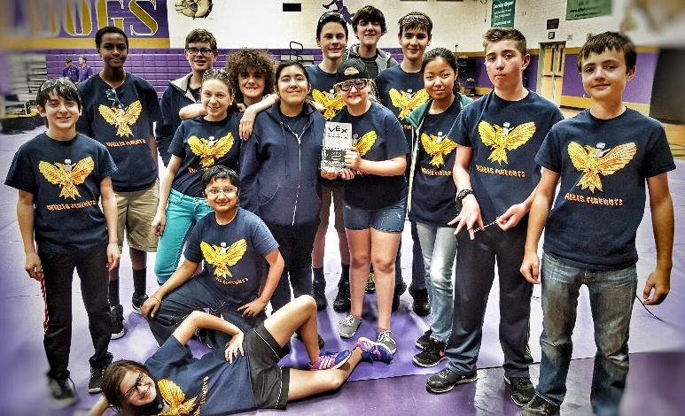
In order to address the diversity on our campus, Willis has implemented a number of programs to ensure that student needs and interests are met. We have honors and gifted programs, as well as English immersion classes and intervention programs to meet the needs of students who are struggling academically. We offer STEAM (Science Technology Engineering Arts and Mathematics) based curricular programs, engineering classes, a nationally recognized and much awarded music program consisting of jazz, concert, orchestra, and choir, National Junior Honor Society (NJHS), and more. More information on these programs can be found on the Willis Junior High website at http://www.mychandlerschools.org/Domain/4170.
The 2015-2016 Willis Firebots Robotics Team

The Willis Firebots Robotics Team

The Willis Junior High School Firebots Robotics Team consists of twenty students, eight girls and twelve boys. There are five students on each of the three competing teams and five students that serve as the Support Team for the competing teams. The backgrounds, skills, and strengths of the team members are as diverse as the Willis student population.

VEX Robotics Platform

The VEX Robotics Design System offers students an exciting platform for learning about areas rich with career opportunities spanning science, technology, engineering and math (STEM). Every April a new game challenge is released. The game for the 2015-2016 season is called Nothing But Net. Visit http://www.vexrobotics.com/vex/competition/competition-resources/ for a video and description of the game.
The Engineering Design Process
Students must design, build, program, and operate robots to meet and exceed the challenge. Once the new game is released, students apply an engineering design process towards developing solutions to the challenge.
Students will learn and apply an engineering design process in their attempt to tackle this challenge. This involves …
- Defining the Problem – Analyzing the rules and identifying the problems, criteria, constraints, and tasks that must be met and performed in order to be successful.
- Brainstorming – Brainstorm design ideas for all the parts of the robot that could potentially meet each task. It is important that students understand that all ideas are welcomed and none are judged or declined at this point.
- Researching – This includes understanding engineering and science principles like stable building techniques, projectile motion, trajectory, gear trains and ratios, and more, as well as taking field trips to examine how launching mechanisms like pitching machines, catapults, and air cannons work.
- Developing Ideas - Students create detailed sketches, computer generated renderings of designs, build small scale prototypes using common materials to develop several ideas.
- Choosing the Best Idea – Students use a decision making matrix to decide which ideas will best meet the challenge. The matrix scores ideas against the criteria that the robot must meet. The idea with the highest score is usually the best option. This process is intended to make the decision process more objective, focused on the criteria of the project, and avoid arguments by removing some of the personal attachment students might have to their ideas.
- Building – Then students build their designs.
- Testing and Evaluating – As they build, students must test and evaluate the various features of their designs.
- Improving Design – Students must improve their designs based on the results of their tests.
- Communicating – Students communicate their journey through this process at tournaments when judges interview them. Each team keeps an engineering notebook in which they document their process and learning that takes place. They must submit these for judging at tournaments as well.
Teams typically go through several iterations of their design before settling on a design that works well.
A typical day at a VEX Robotics Tournament

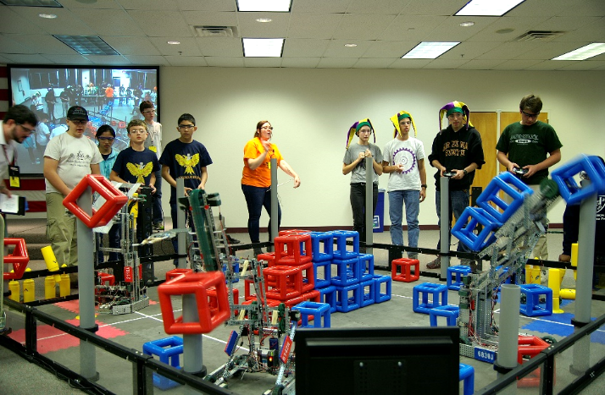
VEX Robotics Competition tournaments are all-day events that begin at 7:30am and last sometimes until 5 or 6 pm. The VEX Robotics Competition is played on a 12 foot by 12 foot field. Two alliances composed of two teams each play against each other to accomplish the challenge and outscore their opponents. This means that there are four robots on the field during one match. Teams compete in 6-8 qualifying matches throughout the first half of the day. Teams are randomly assigned alliance partners for qualifying matches, so they don’t necessarily know the people on the other teams or what their robots can do. They must quickly build relationships with these teams and scout out competitors. During qualifying matches, judges visit the teams and ask questions about how they have designed their robot, the challenges they’ve faced during the process and how they solve them. Teams submit their engineering notebooks to show the record of their work. Students learn that if they don't document it, it didn't happen!
The Firebots in action at the Microchip Qualifying Tournament.

As the day progresses robots break or programming stops working. Students have to be prepared to deal with these challenges and offer their assistance to other teams that need help. Even though teams compete against each other, everyone helps each other out. The atmosphere is one of collaboration.
Throughout the qualifying matches, the Willis Firebots Support Team helps the competing teams by taking photos and video to document and share experiences and watching matches throughout the day to scout out what other teams can and cannot do (which is important information to have when moving into the finals rounds).
After qualifying matches end, the top eight ranked teams choose two teams each to form alliances that consist of three teams. This is when the Support Team’s scouting comes in to play. This helps the competing teams determine the best partners with which to form alliances. These top eight alliances play through a quarterfinal, semifinal, and final round in which the alliance who wins two out of three matches moves on to the next round. The winning alliance from the finals round is crowned tournament champions which qualifies them to participate in the Arizona State Championship tournament.
Learning
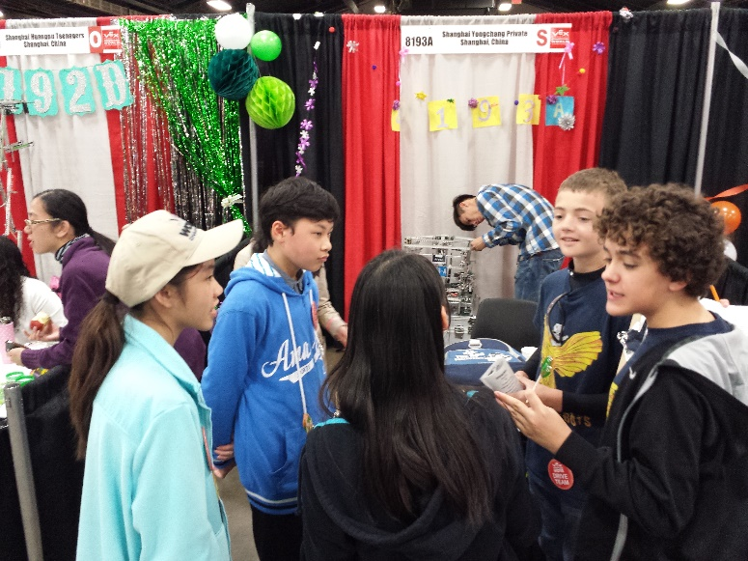
The goal of the Willis Junior High Firebots Robotics Team is to keep junior high kids excited about and interested in learning in the STEM fields. Robotics is the fun hook to get them there. Beyond science and engineering principles, participation in the Willis Junior High Firebots Robotics Team encourages the following skills.
The Firebots building international relations with China at the VEX Worlds Championship in Louisville, Kentucky.
- Teamwork – The three Firebots teams share ideas and resources, collaborate, and support each other as one team. At tournaments, team members meet with their alliance partners, discuss their strengths and capabilities, and strategize about how they can best complement each other’s skills in order to score the most points and win the match. Sometimes they find that they must work with their arch rivals.
- Leadership – Each student on team takes on several roles and must make sure that various tasks are accomplished. Each team also has a project leader.
- Problem solving – Students must troubleshoot and solve problems when robots aren’t working like they want them to work.
- Persistence – Students must persevere through to completion, stay focused, and look for ways to solve problems.
- Think Flexibly – Generate plenty of alternatives and consider all the options.
- Record and Document – Teams document all meetings and work in their engineering notebooks to the specifications that are required of such a document.
- Take Responsible Risks – Failure is part of the process. Students become comfortable with taking responsible risks, learning from them, and venture out of their comfort zone.
- Growth Mindset – Students realize that they don’t always have all the answers and that there is always more to learn in order to be successful.

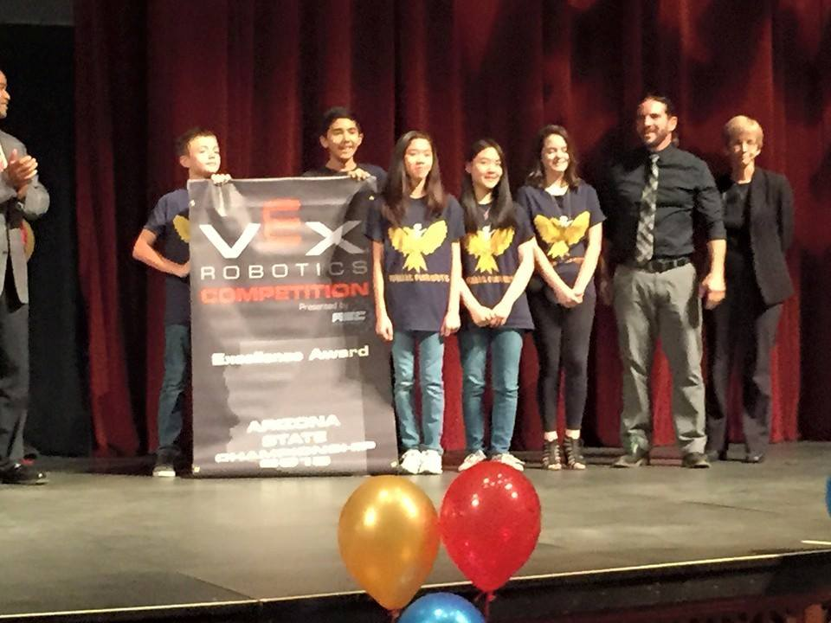
Outcomes and Awards
The Firebots receive the Arizona Excellence Award

The Firebots had a successful year. The Firebots participated in seven qualifying tournaments and brought home a Sportsmanship, Design, Teamwork, and two Excellence and Judges Awards. In addition to garnering these accolades the team were also Tournament Champions at the Arizona College Prep Tournament and at the Madison Highland Prep Tournament.
All three teams qualified and competed in the Arizona State VEX Championship Tournament at Arizona State University. All teams made it to the semifinals round and one team won the Design Award. One of our teams has qualified to participate in the VEX Worlds Championship Tournament in Louisville, Kentucky. Last year, the Firebots competed with 150 middle school teams at the Worlds tournament and placed 49th in their division. Not bad for a first appearance!
Budget Needs

The goal is now to meet and hopefully exceed the next challenge and build upon the successes of this year. Eight team members will return as 8th graders for the 2016-2017 season. A new group of eager 7th graders is coming up from Willis’ elementary feeder schools. Our goal is now to qualify for and return to the Arizona State Championship tournament in 2017.

In order for all this to occur, the Firebots will need funding. We require new field and game objects so the team can practice. Students need new parts to develop their ideas and build their robots. We require new Robot C software licenses for programming the robots. Students will need new team jerseys. And we will incur registration fees for tournaments throughout the year.

Willis Firebots Robotics Team Projected Expenses
Item | Description | Price | Quantity | Total
Team Registration | Teams must be registered through the Robotics Education and Competition Foundation to participate. | $100.00 | 3 | $300.00
VEX Field & Game Objects | These are the official competition objects the team will need in order to test and evaluate their designs and practice. | $600.00 | 1 | $600.00
Arizona Tournament registration | Each tournament has a fee that is charged to help cover the cost of putting on the event. | $50.00 | 18 | $900.00
Robot C Programming software | This is the software used to program the robots. | $300.00 | 1 | $300.00
Parts | Parts must be replenished each year. | $5,000.00 | 1 | $5,000.00
team t-shirts | Helps build team identity. | $20.00 | 25 | $500.00
Arizona State Championship Tournament Registration | The Firebots have qualified for the state tournament every year for the last four years. | $100.00 | 3 | $300.00
Hosting the Willis Junior High Qualifying Tournament | We host an annual VEX qualifying tournament at our school. | $1,200.00 | 1 | $1,200.00
Total estimated expenses for the 2016-2017 season (3 teams) |  |  |  | $9,100.00

Sponsorship Levels

Team Partner $3000 –
We are seeking organizations who would like to serve as Team Partners by funding one of our three competing teams at an estimated cost of $3000. If you wish to be a team partner, your organization’s logo will be prominently displayed on one of our three competition robots in addition to our website, banner, and team t-shirt.

If this amount is cost prohibitive, we have set up several sponsorship levels. Please consider one of the following options.

Parts Sponsor $1500 – Help the Firebots see their visions come to life by funding the parts they need to build their designs.

Willis Tournament Sponsor $1200 – Help us put on a wonderful experience for all the teams competing at the Willis VEX Qualifying Tournament in December.

Competition Sponsor $900 – Help the Firebots participate in tournaments throughout the season by funding registration fees.

T-shirt Sponsor $500 – Help the Firebots compete in style with new t-shirts.

Software Sponsor $300 – Help the Firebots program their robots to be precision machines.

Should you choose to sponsor the Firebots, your organization’s logo will appear on our team jerseys, team banner, and our team website.
Once you have determined the level at which you would like to sponsor the Willis Firebots, please contact Jason Prichard directly. Please make your tax deductible contributions payable to Willis Junior High School and designate for Robotics Club in the memo section of the check.
Please consider supporting one of our teams. Thank you for your time and consideration.
Sincerely,
Jason Prichard
Willis Junior High School
401 South McQueen Road
Chandler, AZ 85225
7th/8th grade Science and Engineering
Phone: 480.883.5700
Email: Prichard.jason@cusd80.com

